**Week 2 report**

**Task 1:** In task 1 I have used pandas library to save user’s input to a dictionary. In this code user is able to give the name,age,email and favourite number as input. This code will display the output as hello [name],you are [age] years old, yous email is [email], and your favourite number is [favourite number].

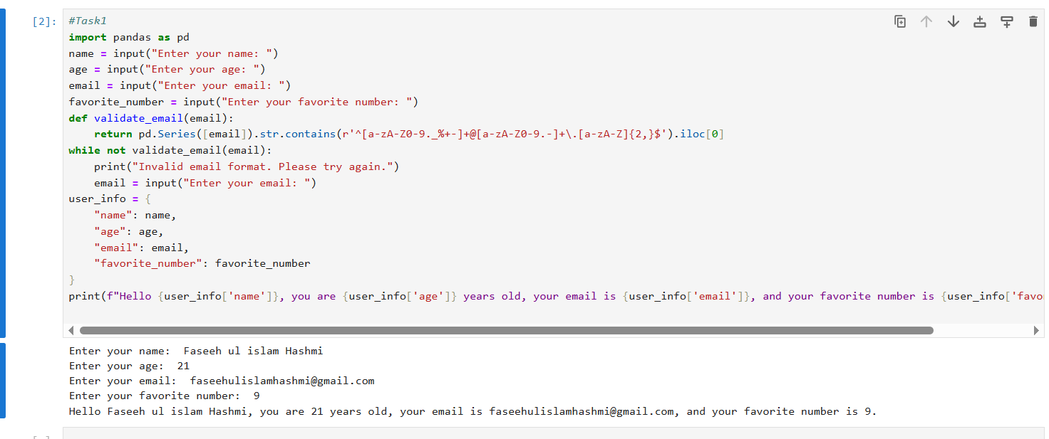

**Task 2:** In this code I have defined a function (is_even) which will use if-else condition to predict wether the number user entered is even or odd. It divides the inputs number by 2 and if the result is 0 it displays the output as even else it displays odd number.

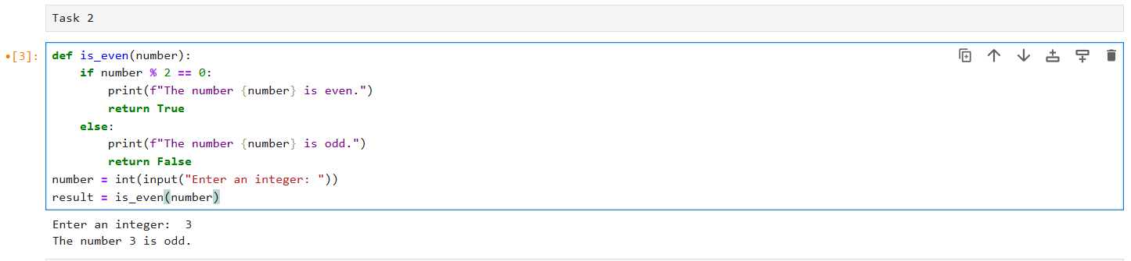

**Task 3:** In this code I have defined the function (convert_temperature(temp,scale)) which takes temperature and scale of temperature as Celsius or Fahrenheit from user as input and converts the temperature. If the given temperature is in Celsius it converts it by multiplying the given temperature by 9/5 and adding 32 in it. And if the given temperature is in Fahrenheit it converts it into Celsius by subtracting 32 from it and then multiplying 5/9 in it. Then it displays the output as [temperature] is equal to [converted temperature].

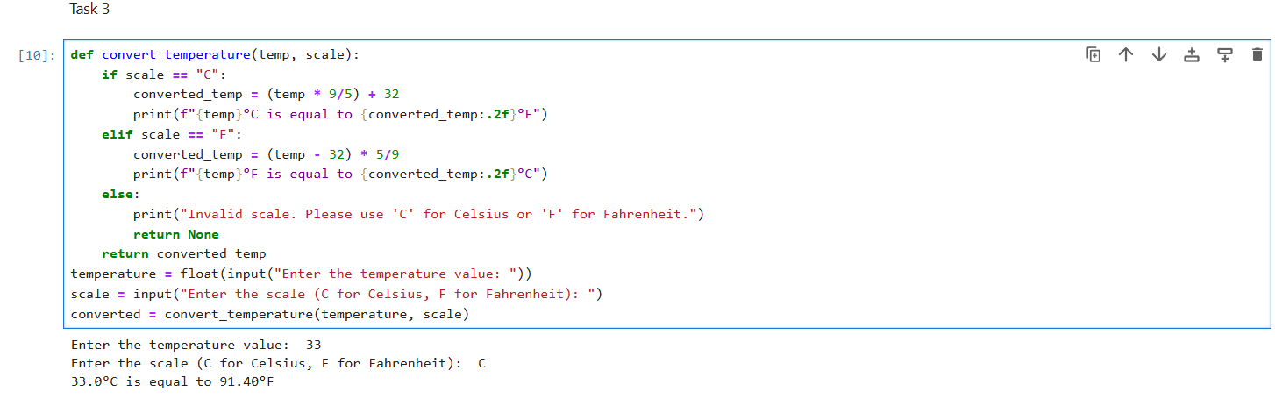

**Task 4:** In this code I have defined a function (find_max_min) which will find the maximum and minimum number from the list of numbers which the user have entered as input. I have used (for loop) for input it will take numbers one by one from user and append these numbers to a list which is named as (numbers_list) . At last I called the function which will give us output by displaying the maximum and minmum numbers.

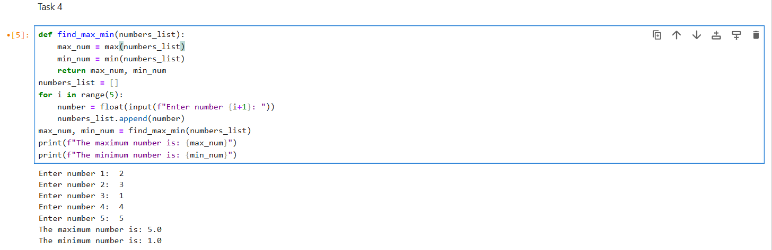

**Task 5:** This code will display the details of students user have entered as input. This code will take details of only 3 students and save in list named as (students). For input I have used for loop which takes name, age and grade of students one by one. After that the input will be converted into dictionary called (student_dict) where the students name is the key and age,grade are the values.

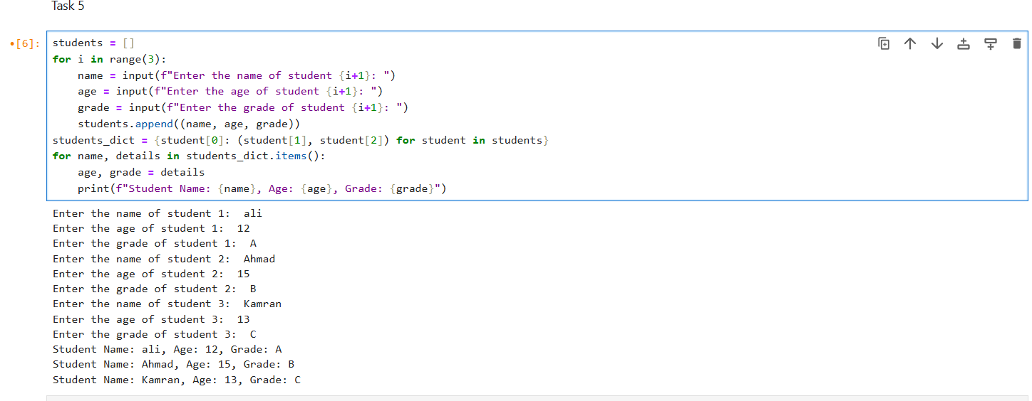

**Task 6:** In this code I have defined a function (update_inventory) which will update the item and its quantity as user wants to update. I have added some items in inventory user can update these items or can add new items in inventory. If the user wants to add new item he has to update the quantity with maximum value 0 but if the item is already present in inventory and wants to update the quantity he has to enter the positive number if he wants to increase the quantity and has to enter the negative number if he wants to decrease the quantity.

